**Unit Three: Exploring Holidays Around the World**

**Lesson 12: Christmas and Easter**

Name: __________________________________ Date: _______________________

**Christmas Here and Christmas There**

Here we think of Christmas as cold and white.

The glistening snow is a pretty sight.

With holly, mistletoe and Christmas lights,

Strung on the tree that shines so bright,

And carols are sung in the icy night,

With everyone bundled up warm and tight

Christmas here is also bright,

But we celebrate it under the summer’s light

We swim at the beach until twilight.

Then in our warm sweet night,

We gather to sing and have a bite.

We exchange gifts and…

Oh, what a delight!

1. **Referring to the above poem, write a short paragraph showing two similarities and two differences between Christmas in cold and in hot places.**

____________________________________________________________________________________________________________________________________________________________________________________________________________________________________________________________________________________

1. **Rewrite each line from the poem correcting the mistakes in each.**
2. The sparkling ice is a pretty scene.

____________________________________________________________________

1. We walk on the beach until sunrise.

____________________________________________________________________

Name: __________________________________ Date: _______________________

1. **Read the following sentences. Replace each underlined word with a correct pronoun.**
2. Hady will buy a book. _________________
3. Miss Itani teaches Mathematics. _________________
4. The children put the toys in the box. _________________
5. Sandra and Alice are good friends. _________________
6. The weather is hot outside. _________________
7. The boys decided to run a race. _________________

**B. Circle the pronoun that best completes each sentence.**

1. Dad bought (I/me) a gift.
2. (He/It) left the gift under the stairs.
3. My two brothers wrote a letter to thank (him/he)
4. (They/him) asked (it/him) to bring (us/we) more gifts.
5. (We/ It) were happy with the presents (her/he) gave (us/she).
6. **Choose four different pronouns (two subject pronouns and two object pronouns) and use each in meaningful sentences about giving a gift to someone.**
7. ___________________________________________________________________
8. ___________________________________________________________________
9. ___________________________________________________________________
10. ___________________________________________________________________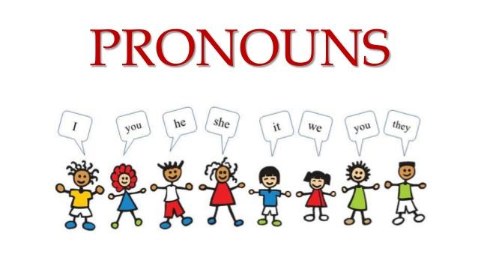

Name: __________________________________ Date: _______________________

1. **Imagine that you have received a special gift from Santa or someone else and you want to thank that person. Write a thank you letter below.**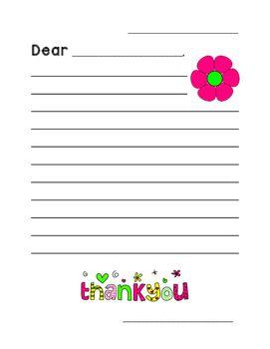

Name: __________________________________ Date: _______________________

1. **Look at the pictures, then add (ee) or (ea) to complete each word.**





s__ __l p__ __ s

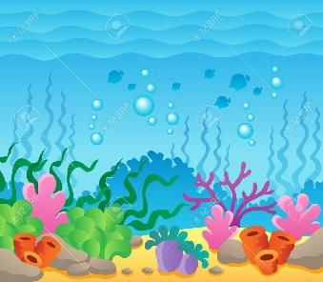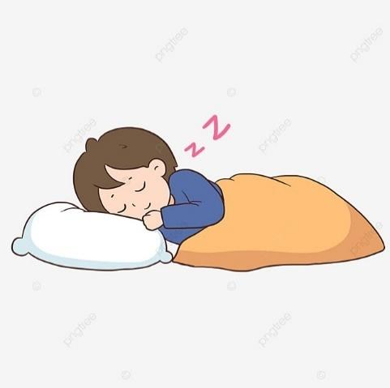

s__ __ sl__ __p 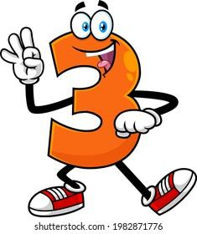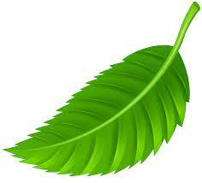

thr__ __ l__ __f 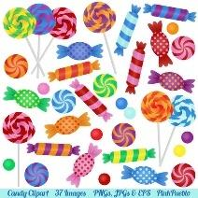

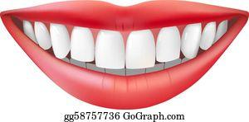

t__ __th sw__ __ts

1. **Write four words, two with (ee) and two with (ea) from your own. Then use each in a sentence.**
2. __________________________________________________________________
3. __________________________________________________________________
4. __________________________________________________________________
5. __________________________________________________________________

Name: __________________________________ Date: _______________________

1. **Read the words in the chart below. Find the words that can be changed into nouns by adding the suffix -ness and color them with green. You can color the rest of the words with any color of your chose.**

| kind | sweet | sour | color | hope |
| --- | --- | --- | --- | --- |
| happy | dark | home | snow | ice |
| leaf | quiet | sad | hot | ill |

1. **Add the suffix -ness to the words you found and colored with blue and write them on the lines below.**

**_________________________________________________________________________________________________________________________________________________________________________________________________________**

1. **Now, choose four words with the suffix -ness from the above exercise, and use each in a sentence.**
2. **_______________________________________________________________**
3. **_______________________________________________________________**
4. **_______________________________________________________________**
5. **_______________________________________________________________**

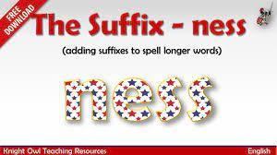

Name: __________________________________ Date: _______________________

1. **Rewrite each sentence using contractions.**
2. We are inviting our friends for my little sister’s birthday party.

_____________________________________________________________________

1. I do not like to eat vegetable soup.

_____________________________________________________________________

1. He is trying to study his lessons on his own.

_____________________________________________________________________

1. It is raining buckets outside today.

_____________________________________________________________________

1. My mom does not cook on Sundays.

_____________________________________________________________________

1. **Imagine you are invited to a birthday party of someone you don’t know well and you will be visiting for the very first time. Write five sentences telling what things you DO NOT have to do in that place. Use contractions in each sentence. Here is an available example.**
2. Don’t laugh loudly because it’s not appropriate.

______________________________________________________________________________________________________________________________________________________________________________________________________________________________________________________________________________________________________________________________________________________________



Name: __________________________________ Date: _______________________

1. **Sequence the following pictures in chronological order. Write 1, 2, 3, 4, 5, 6 under each picture.**

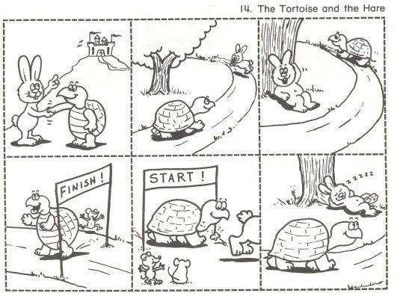

________ ________ ________



_______ ________ __________

1. **After ordering the pictures, write one sentence about each to form a short story about the rabbit and the tortoise.**

________________________________________________________________________________________________________________________________________________________________________________________________________________________________________________________________________________________________________________________________________________________________________________________________________________________________________________________________________________________________________________________________________________________________________________________________________________________________________________________________

Name: __________________________________ Date: _______________________

1. **Fill in the blanks with the suitable word from the box.**

| **stockings** | **legend** | **tradition** | **carols** | **feel** |
| --- | --- | --- | --- | --- |
| **presents** | **glittering** | **pray** | **exchange** | **celebrate** |

1. The best part of parties is receiving ___________________.
2. We sing Christmas _________________ and _________________ to Jesus.
3. We ______________ Christmas at my grandma’s house.
4. Children and adults ________________ gifts in the evening.
5. The gifts are wrapped with a ________________ paper.
6. Eating turkey on Christmas evening is a __________________.
7. People _______________ extremely happy and excited on this occasion.
8. We hang ________________ near the fireplace.
9. Christmas is _______________ celebration for christians.

**B. Choose five words from the above box to write a short paragraph about how you spend Christmas every year.**

______________________________________________________________________________________________________________________________________________________________________________________________________________________________________________________________________________________________________________________________________________________________________________________________________________________________________________________